Assignment for **Oracle E- Business Suite Inventory**

Date:15th Nov-2024

[Provide screenshots of each step (which performed in a live environment).   
As evidence all the activity screens shot needs to be attached]

1. What is the Oracle Inventory module?

2.With you User id switch to: **Vision Operation Inventory**. Responsibility.

3.Choose **VI Inventory Org & Find the master Items.**

4.Take any Item & assign the same Item for all the **Inventory Org.**

5. And Un assign the same Item for all the **Inventory Org.**

6**.** Any of the existing Item [VI Inventory org] Check the on-hand quantity.

7. Unit of Measure (UOM)... with Navigation show where UOM has been defined.

8. How do you create a new inventory item?

9. How to run Inventory Valuation Report?

10.How to change Inventory Organization in the Current responsibility.

11. What is **Master Data** in Oracle Inventory?

12.Show the existing ORG with navigation.

13: You can manage only finished goods in **Oracle Inventory**?

14. You need to create an item before performing inventory transactions **[Ture/False].**

15. Sub inventories are optional in Oracle Inventory. **[Ture/False].**

1. The inventory module is a comprehensive inventory management system. It allows a business to manage and track their inventory all the way from raw materials to finished goods. This module supports the full life cycle of inventory operations, and is a critical piece for managing supply chains in an organized manner.

2. Click the Top Hat icon at the top and select Inventory, Vision Operations.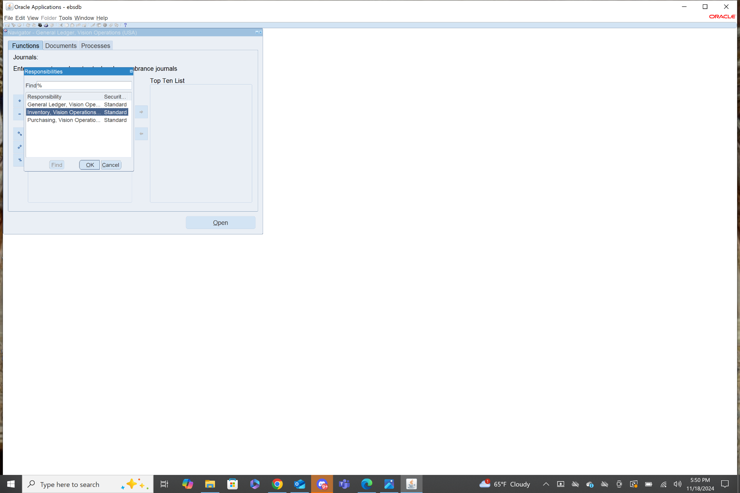

3. Navigation: **Inventory>Change Organization**

Search Vision Operations and select it.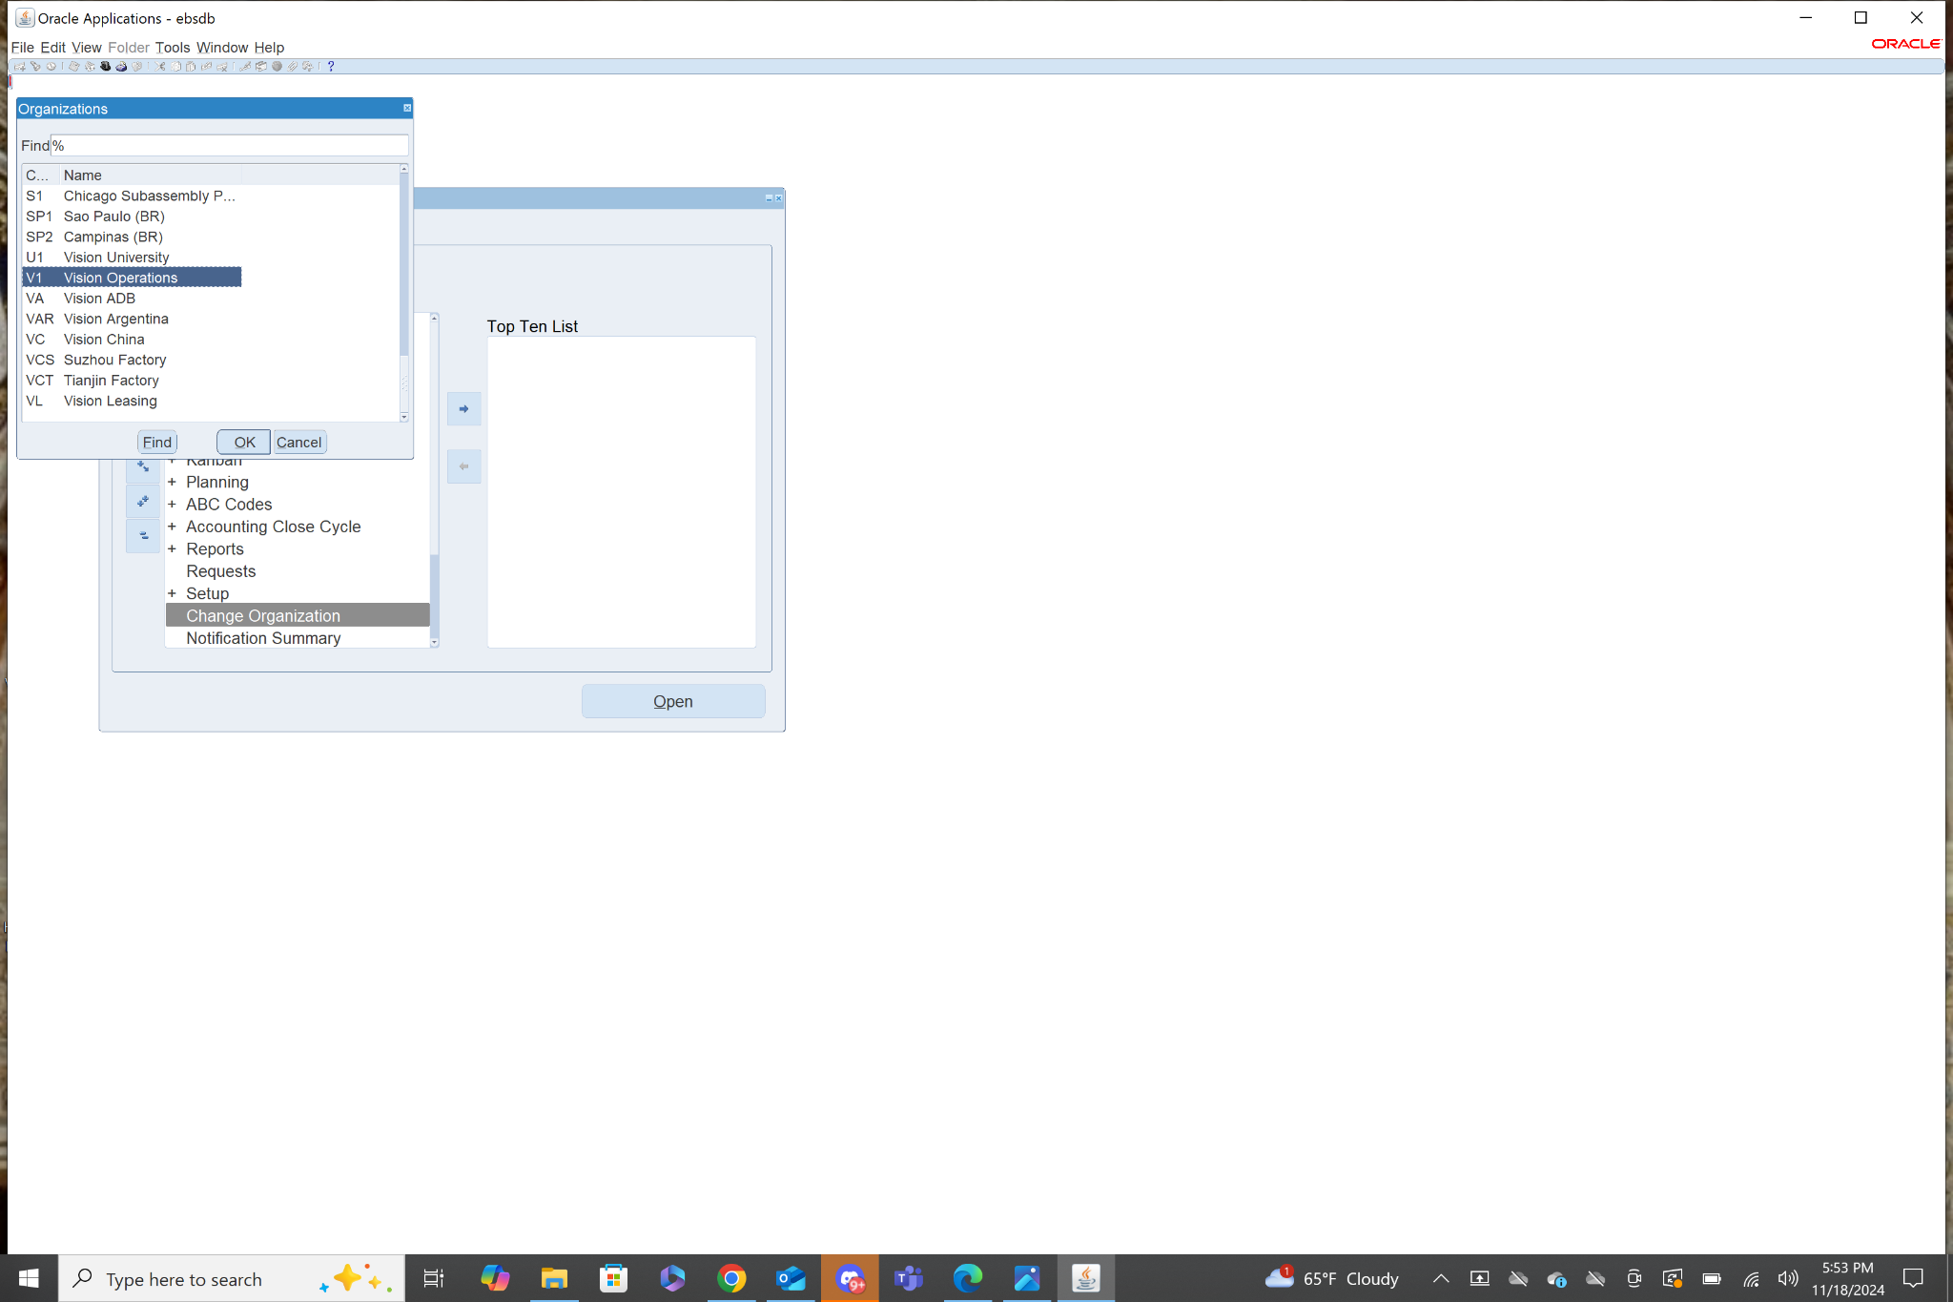

Navigation: **Inventory>Items>Master Items**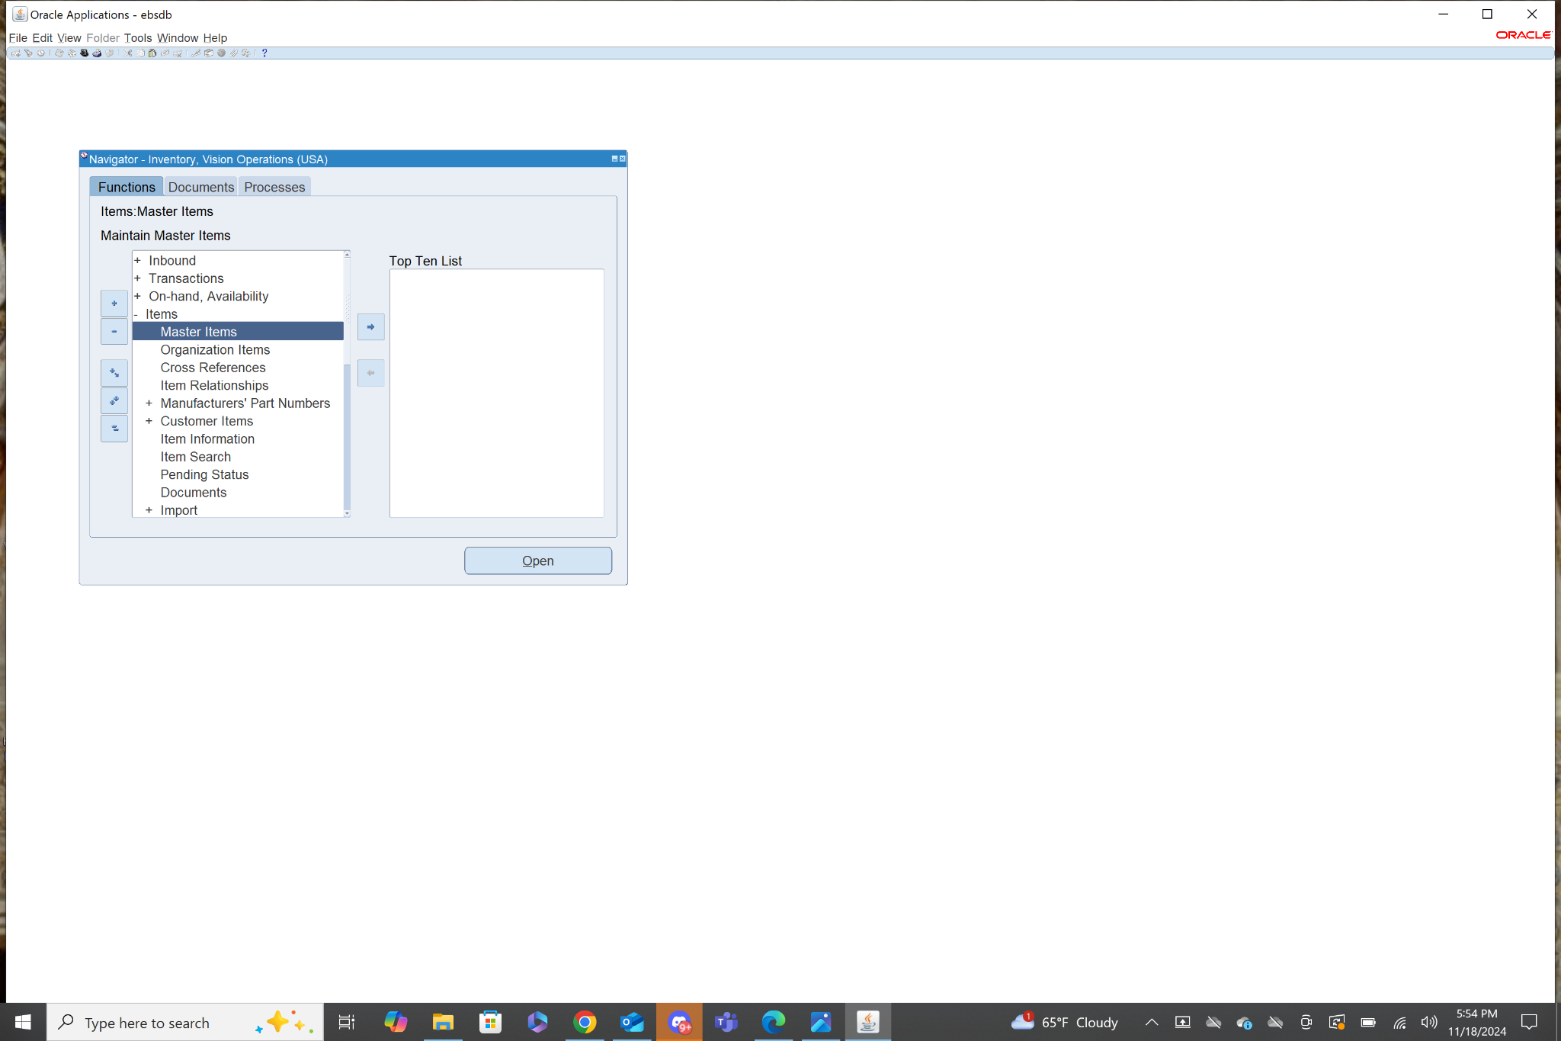

4. Navigation: **Inventory>Items>Master Items**

Use ctrl+fn+f11, choose an item, then select the Organization Tab on the left. Then click Assign All.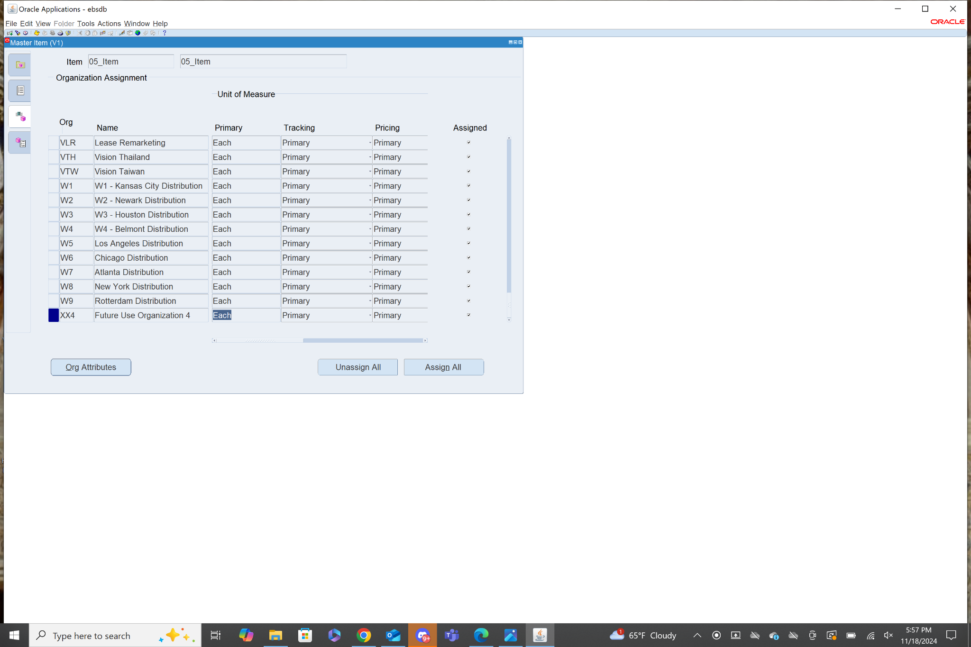

5. Navigation: **Inventory>Items>Master Items**

Select the Organization Tab on the left. Then click Unassign All.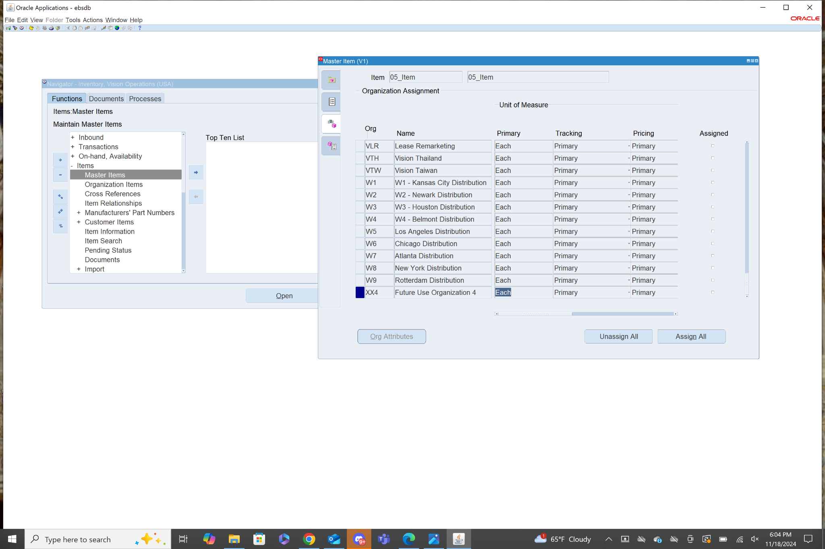

6. Navigation: **Inventory>On-hand, Availability>On-hand Quantity**

First step was to change Organization to Vision Operations. Then I clicked Find.

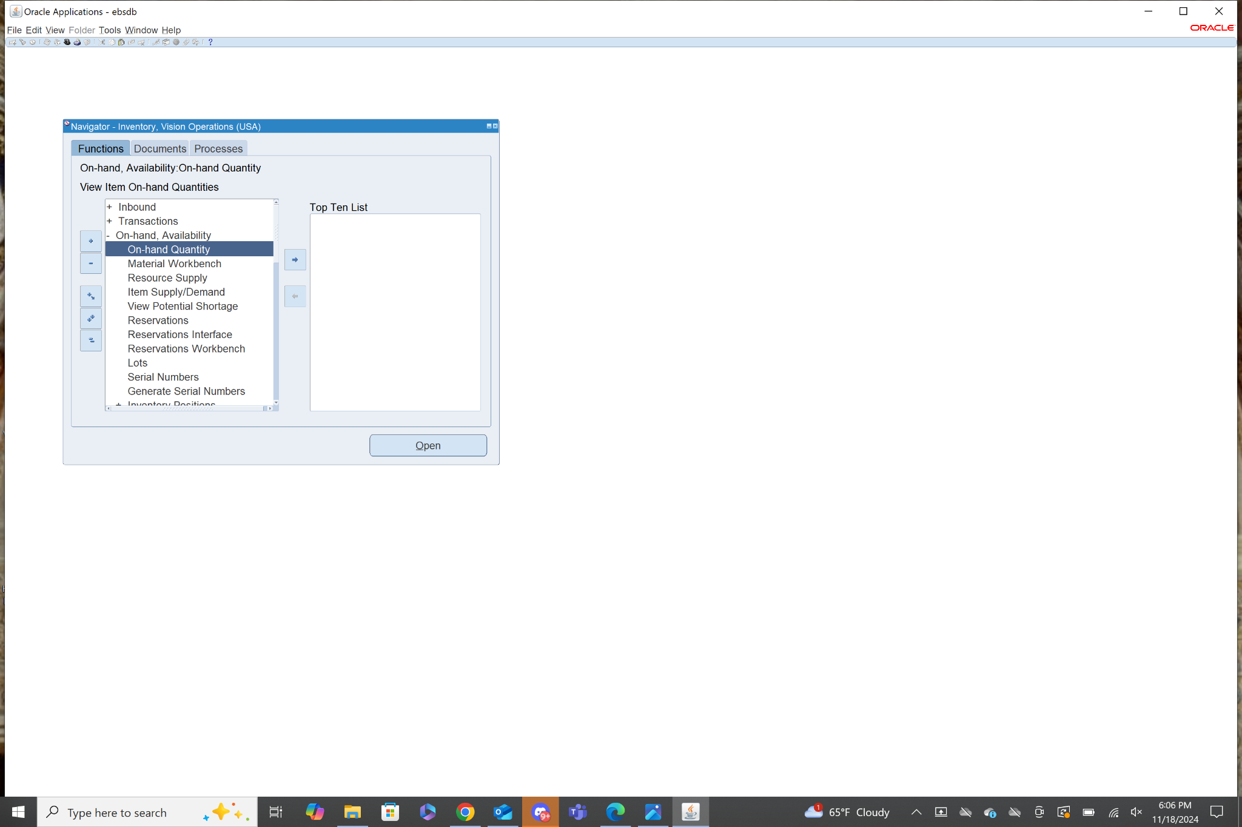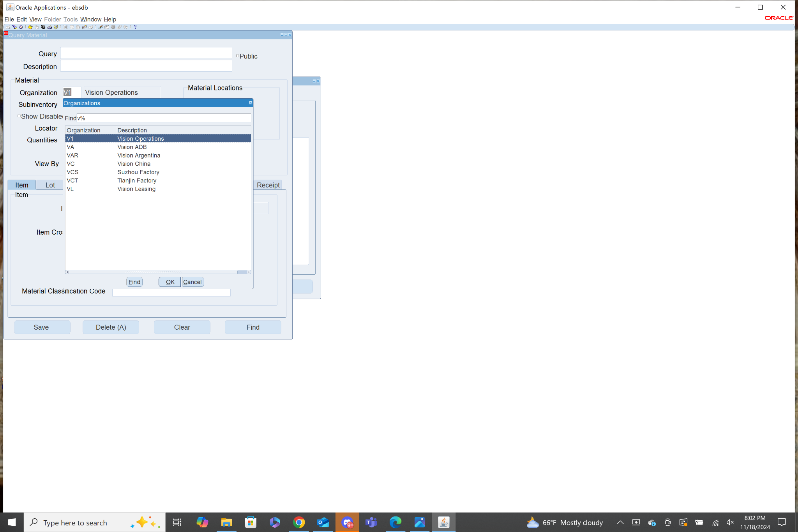

I selected the Item “Seminar-kit” and clicked availability, there were 10 on hand.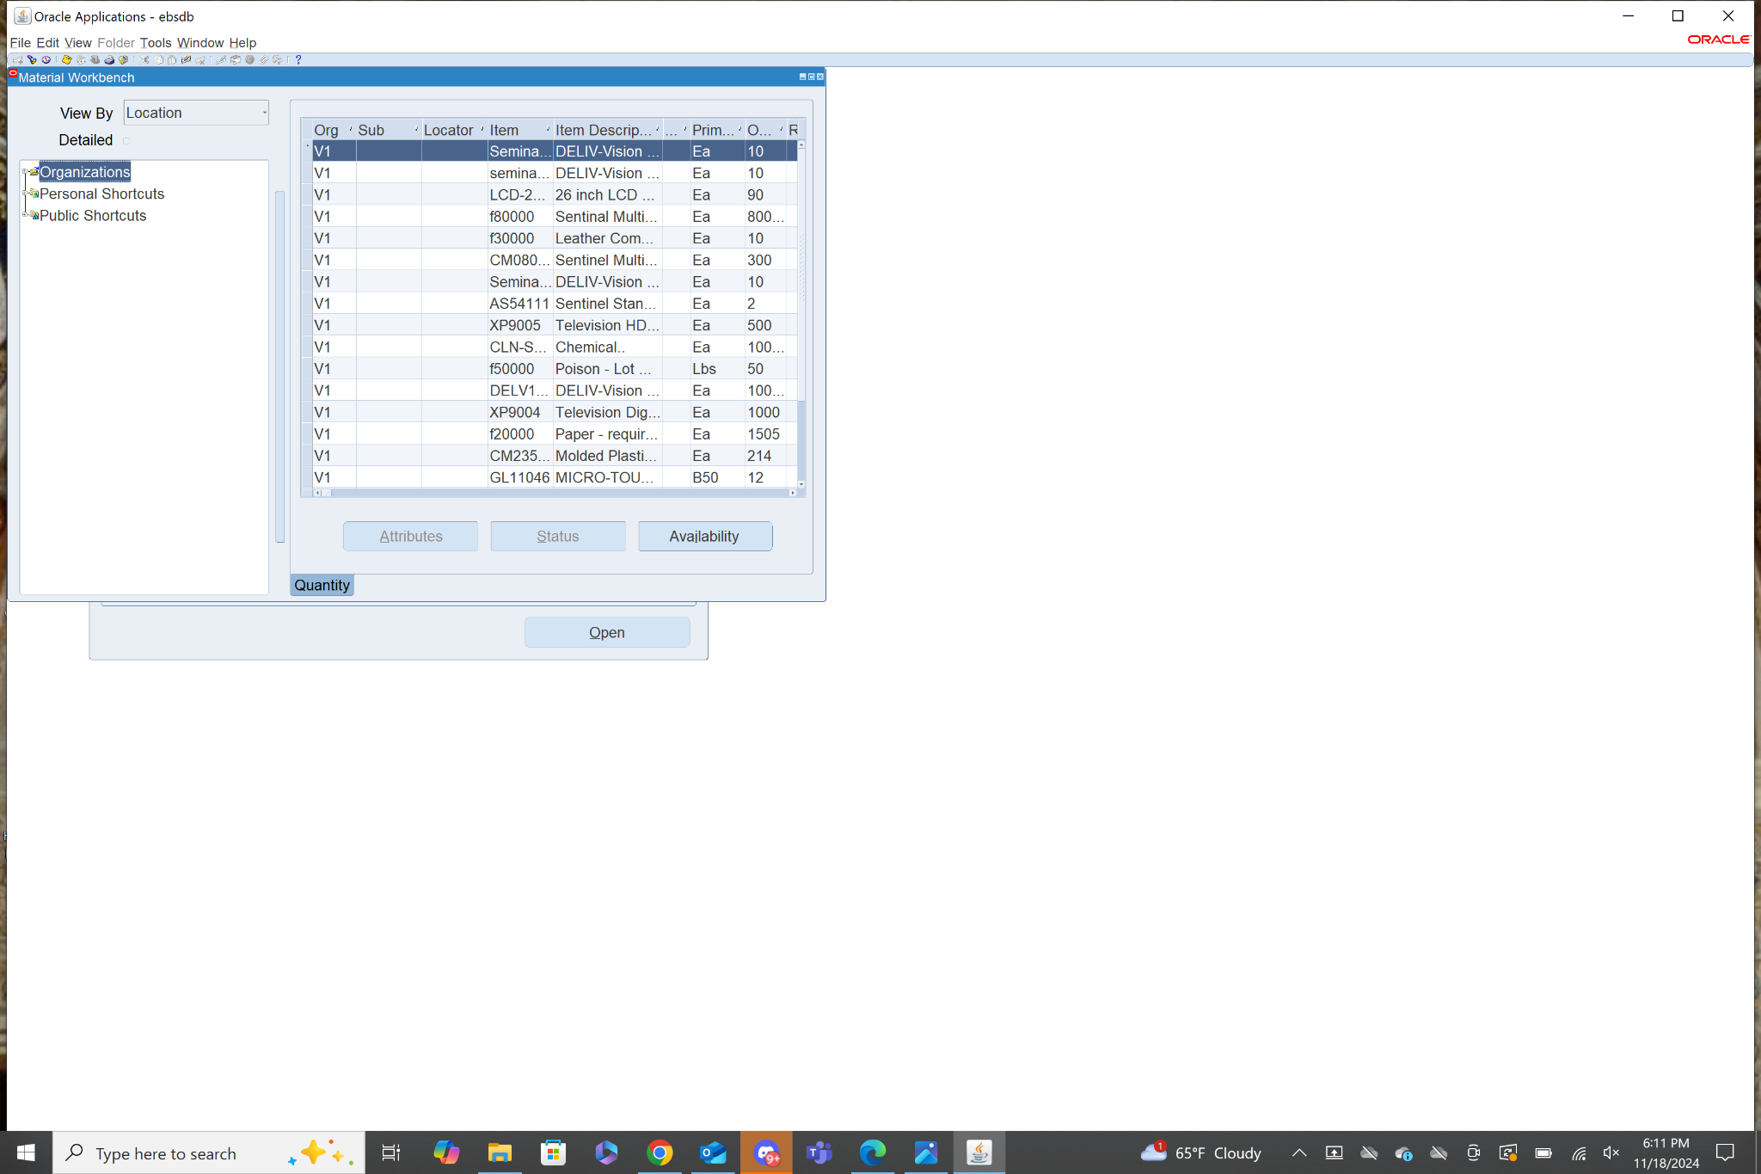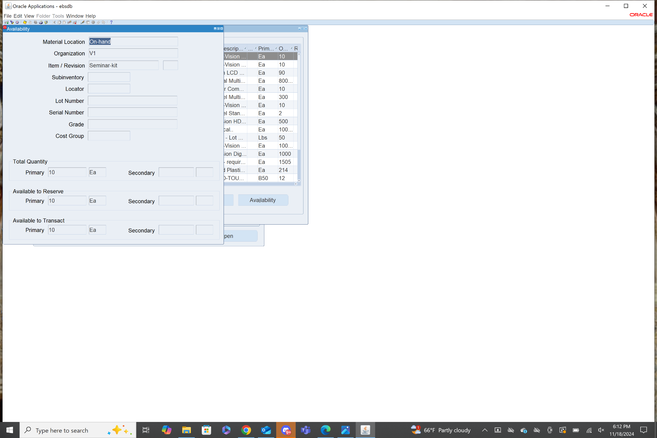

7. Navigation: **Inventory>Setup>Units of Measure>Units of Measure**

This takes you to a menu showing all the Units of Measure have been defined.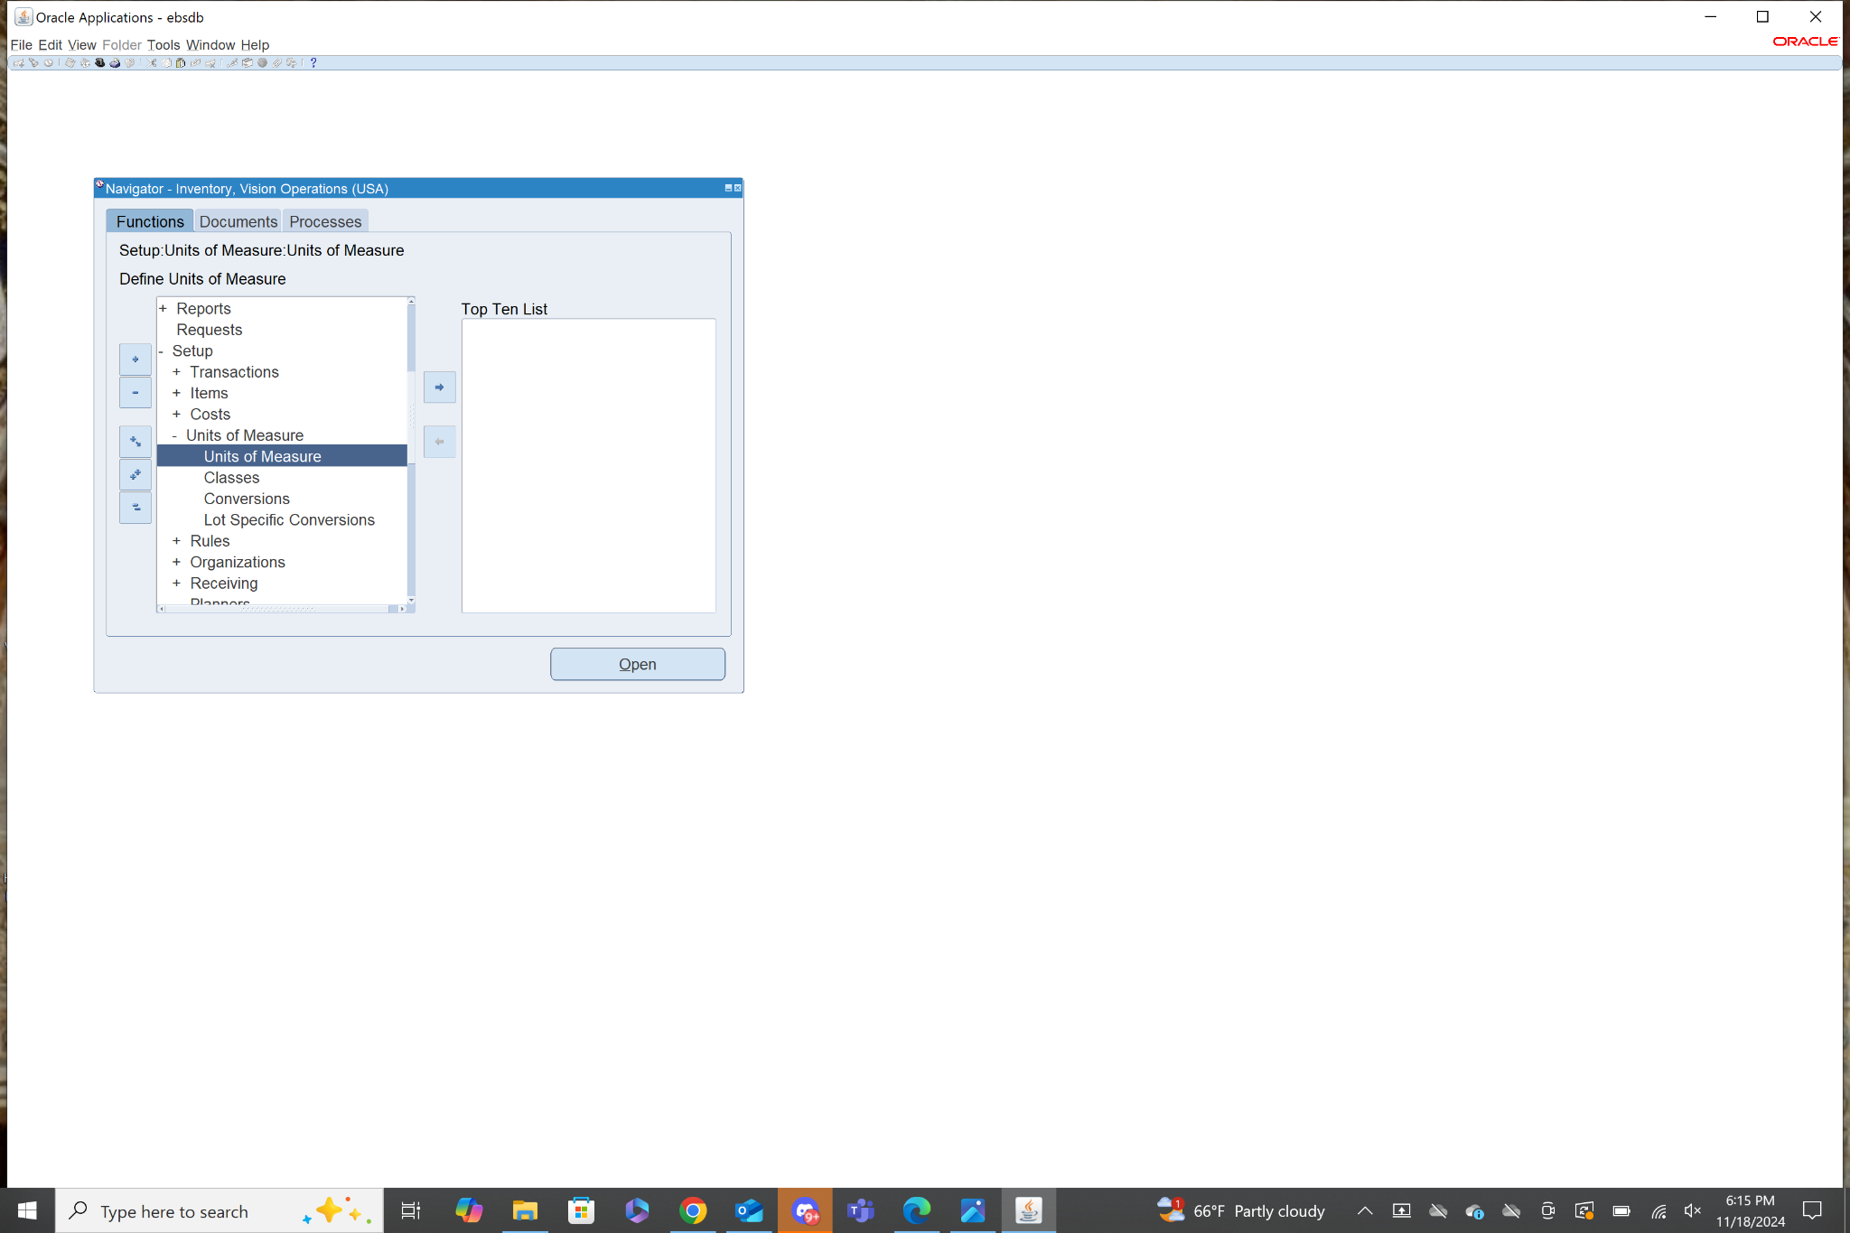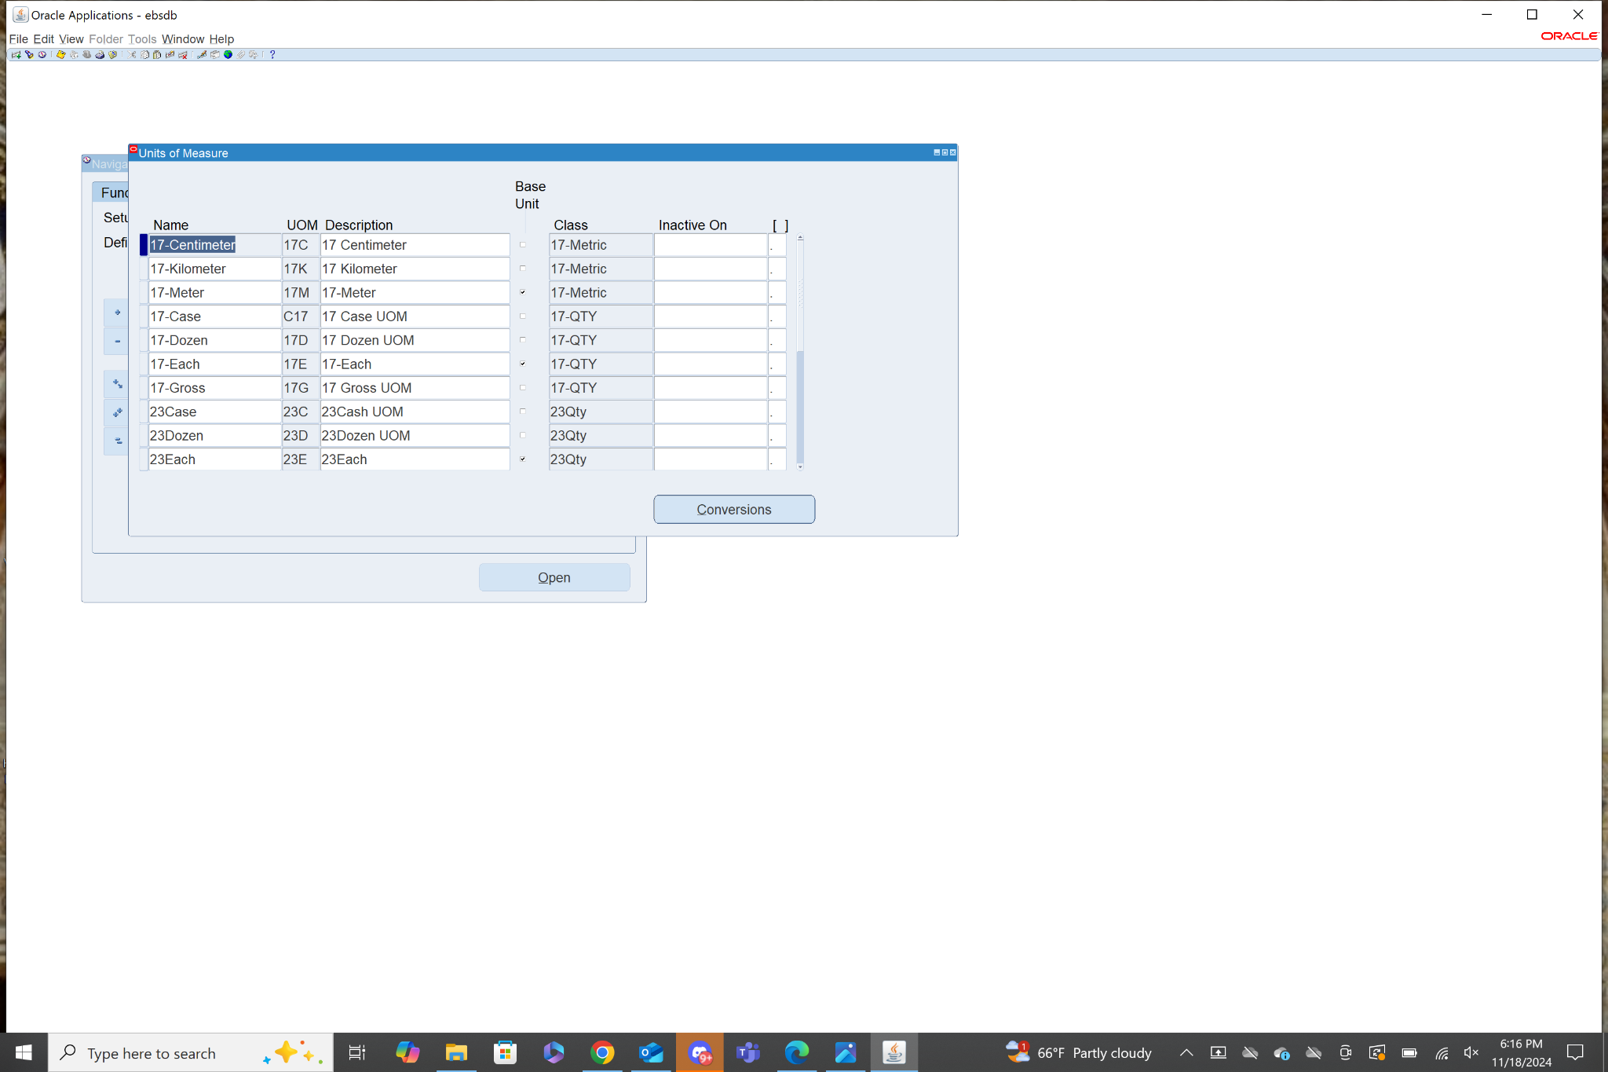

8. Navigation: **Inventory>Items>Master Items**

From the master item menu in the attribute groups tab, you need to define any fields highlighted yellow. All other gray fields are optional. Once you have filled out the necessary fields click the yellow floppy disk icon at the top to save the item.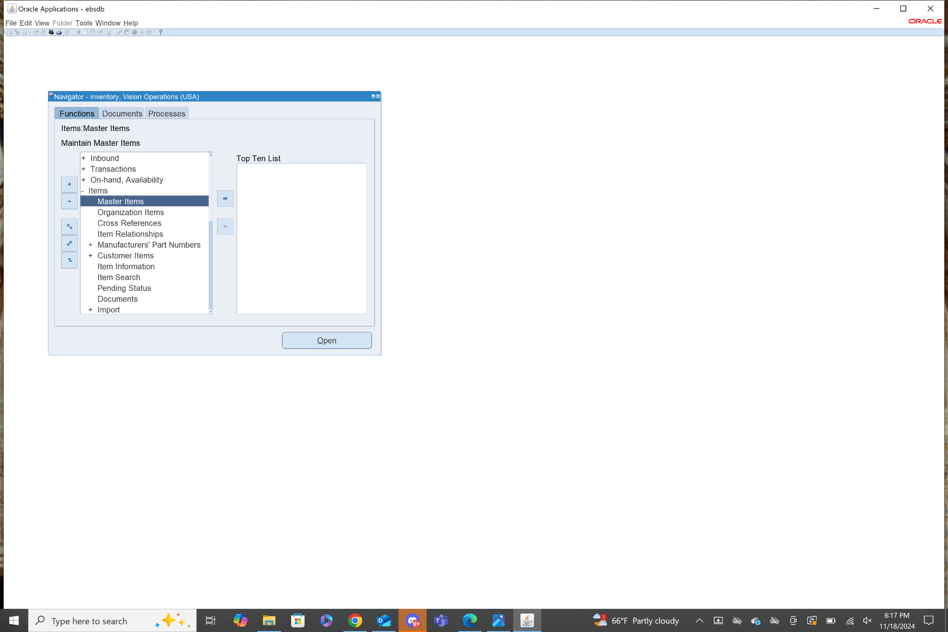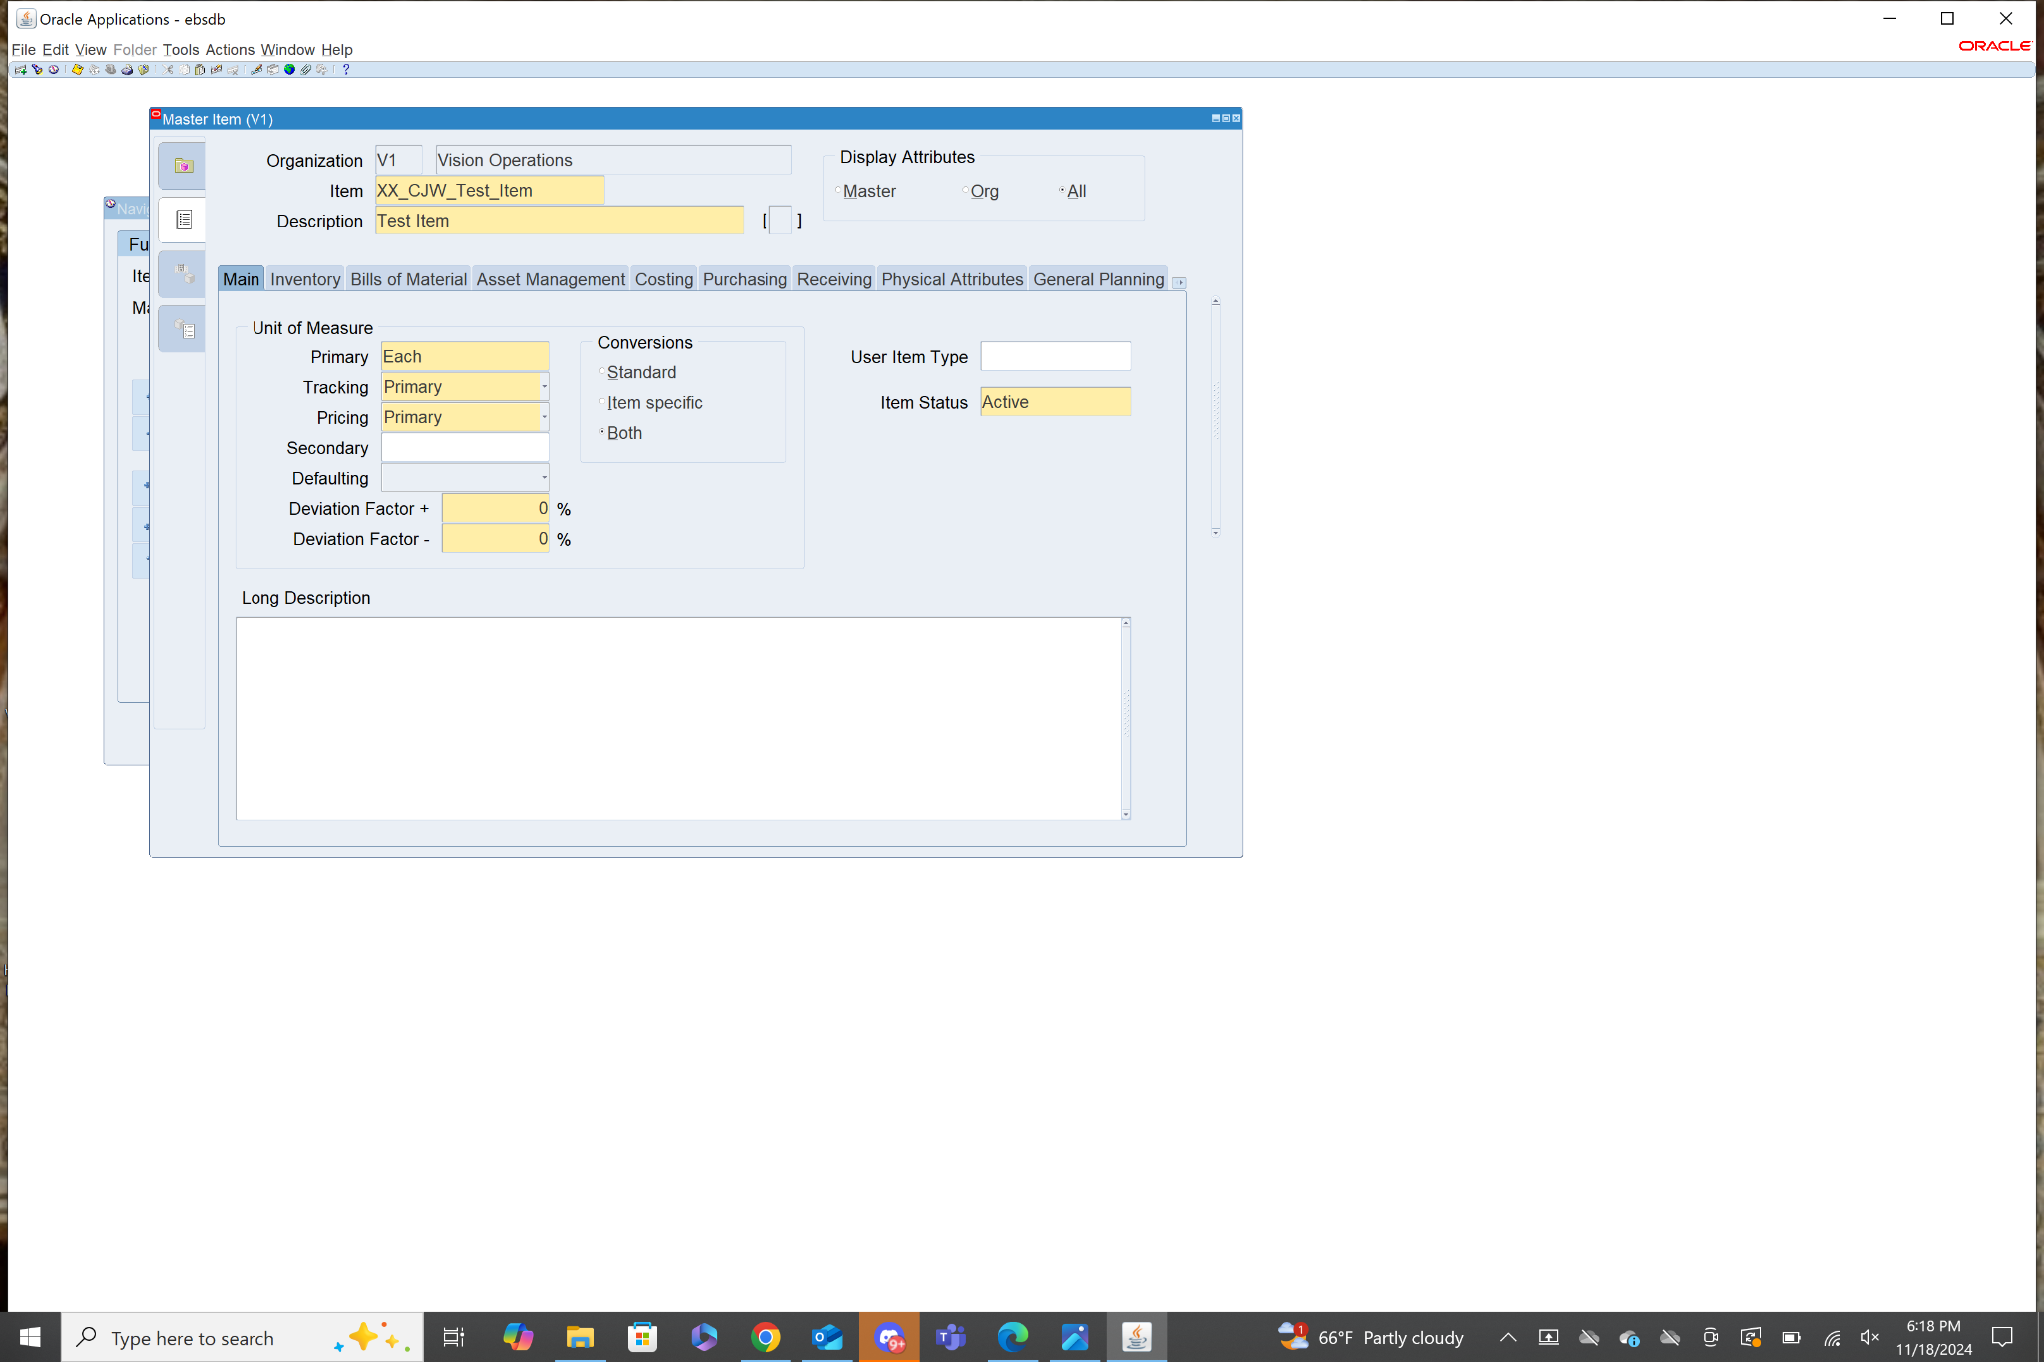

9. Navigation: **Inventory>Requests**

From the Find Requests page select submit a new request.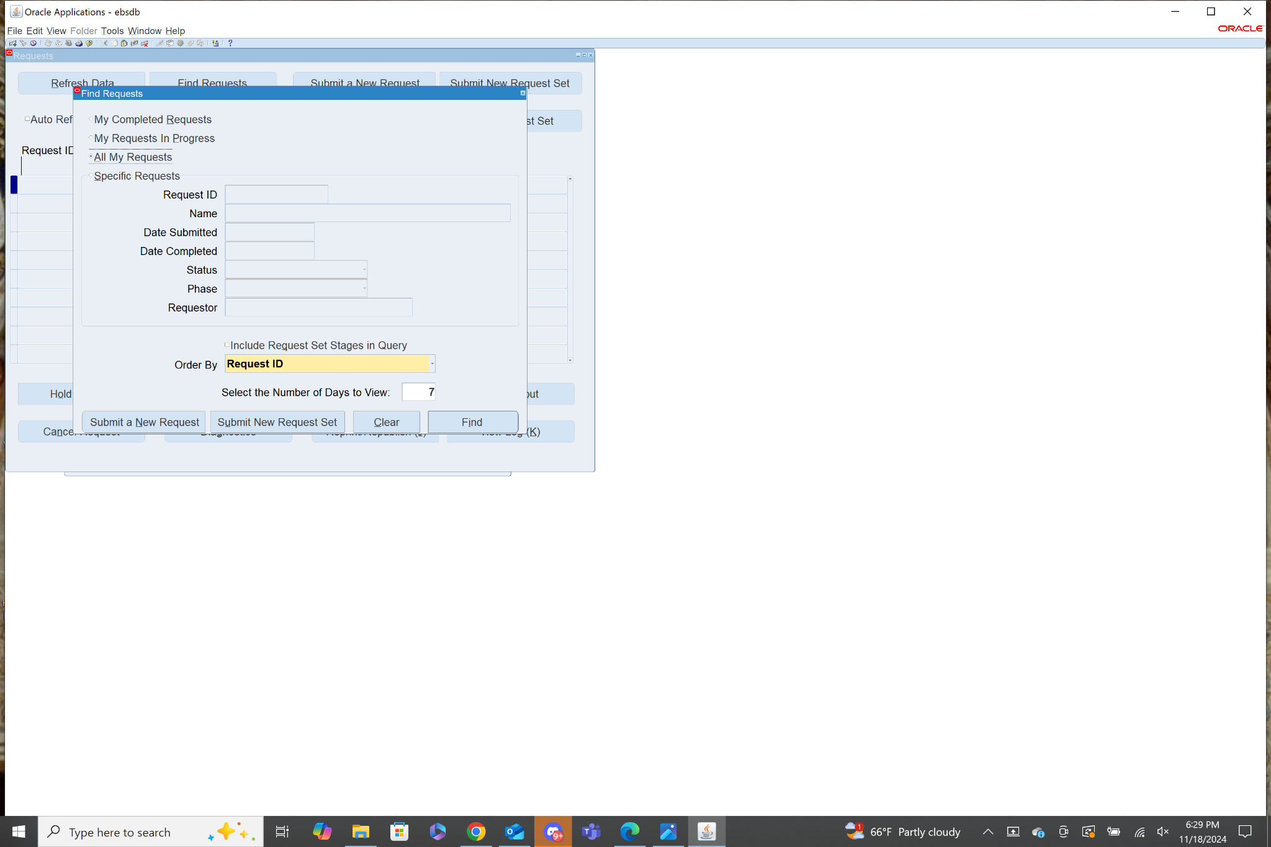

In the name field search “Inv%Val%” from here there are a couple of options. You can run the report by Cost Group or Subinventory, also the output can be default or XML. I will choose by Cost Group - Default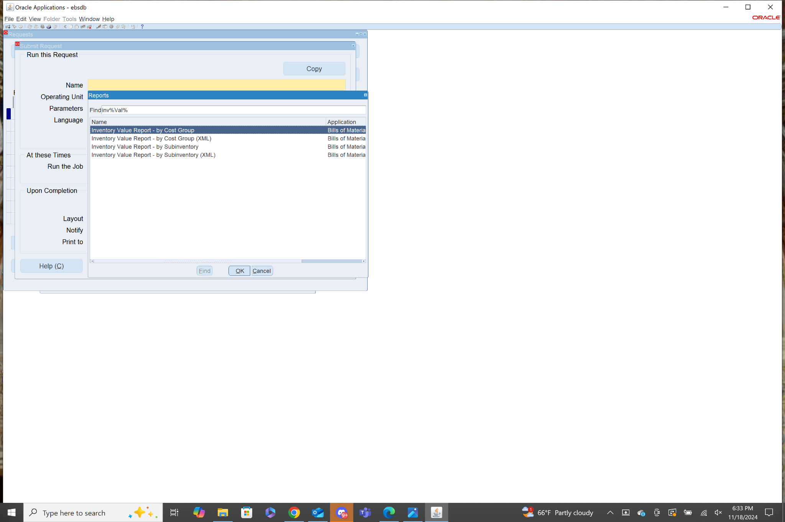

After selecting by Cost Group there is a list of parameters to input, most are autofilled. Exchange Rate I had to change to 1. Then click OK. 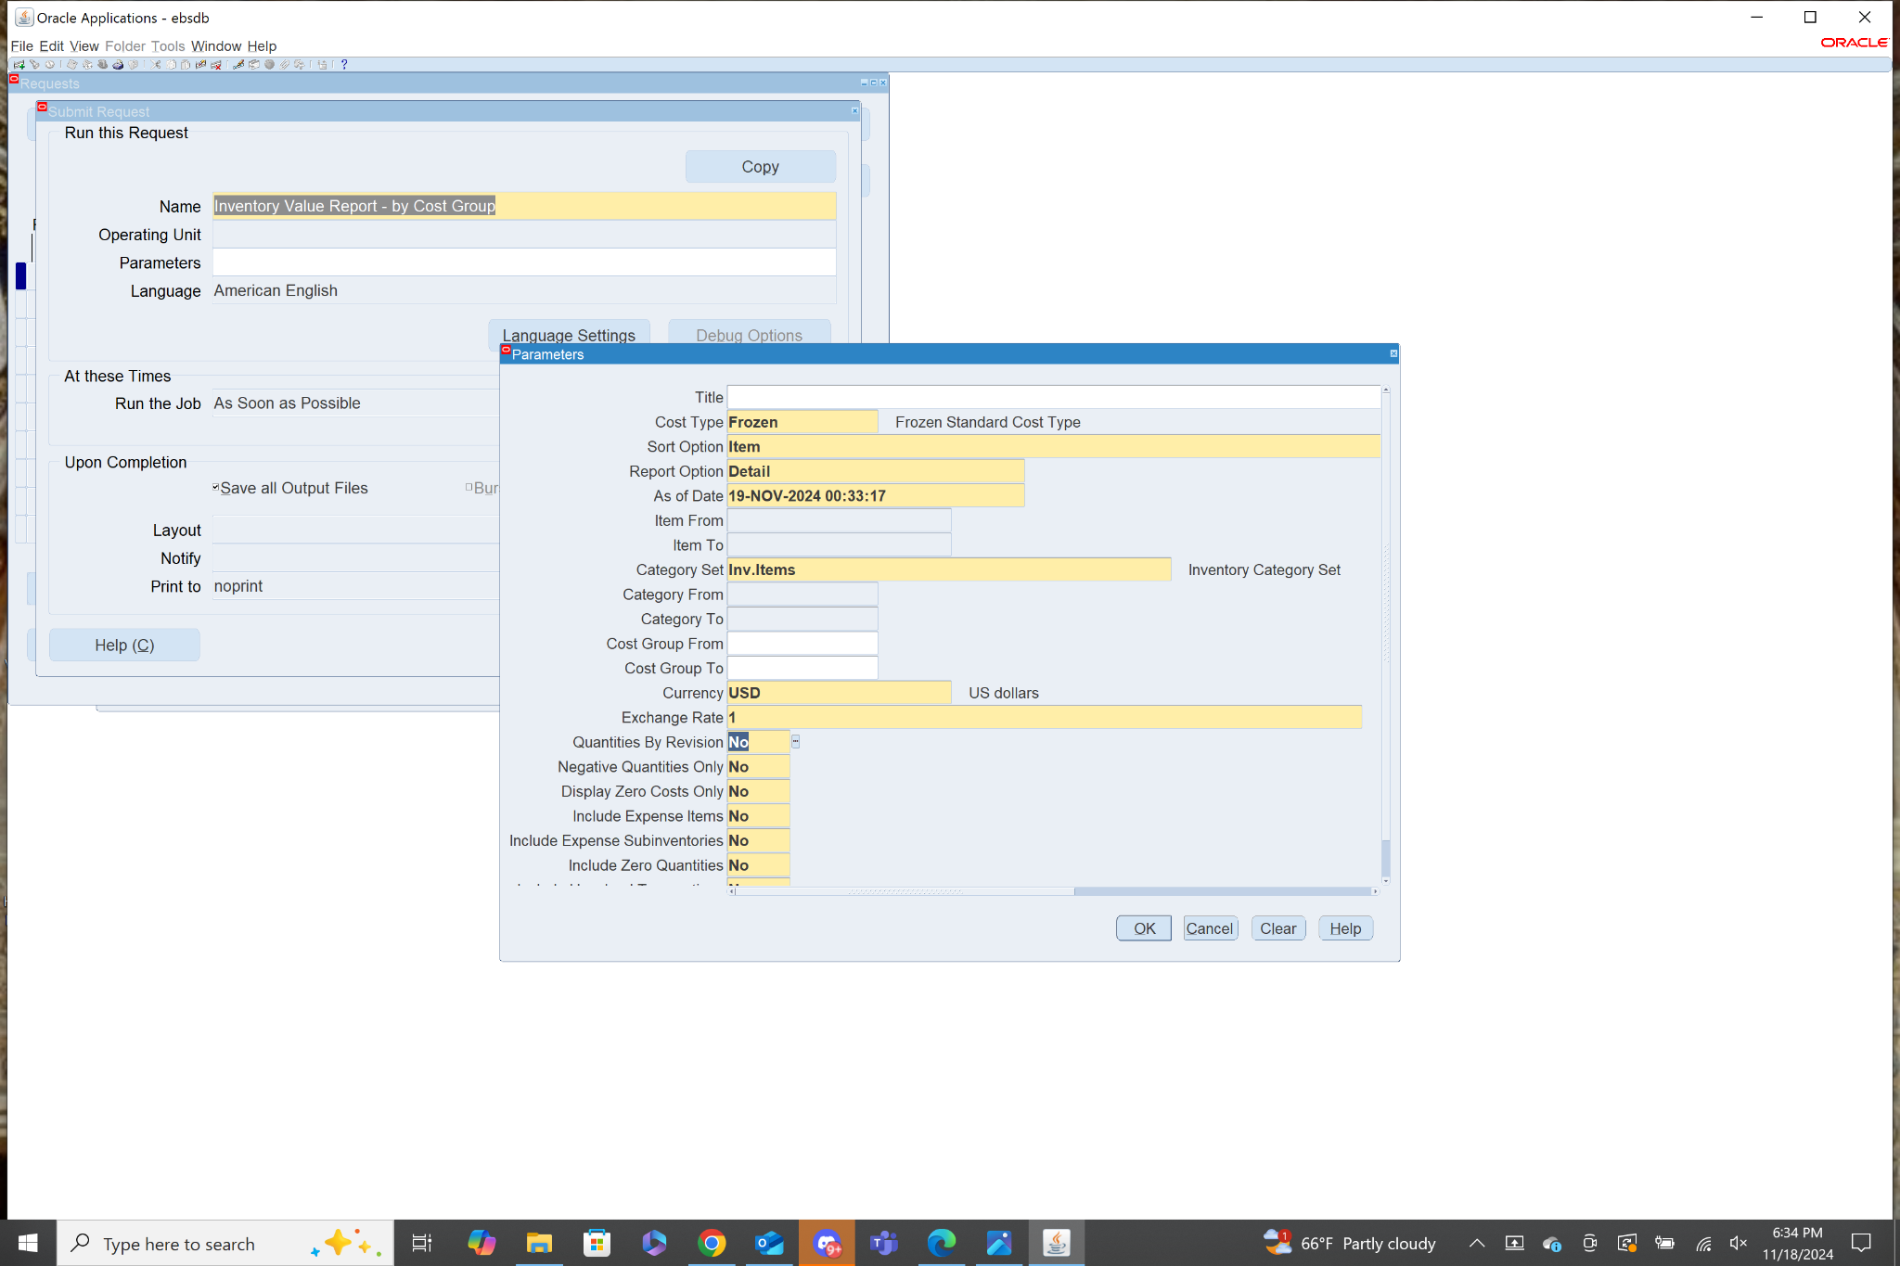

Then at the request page click submit to run the report.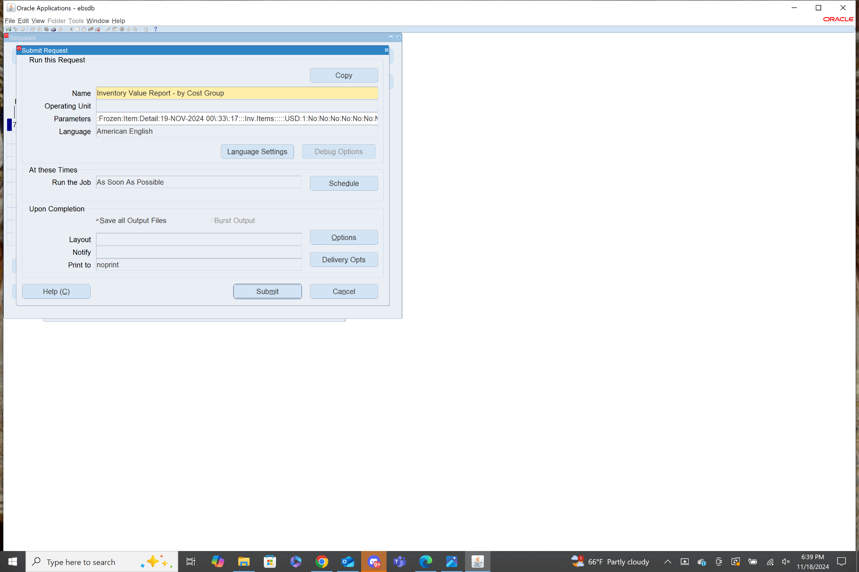

10. Navigation: **Inventory>Change Organization**

After clicking Change Organization you will be brought a menu where you can choose from a list of Inventory organizations to change to.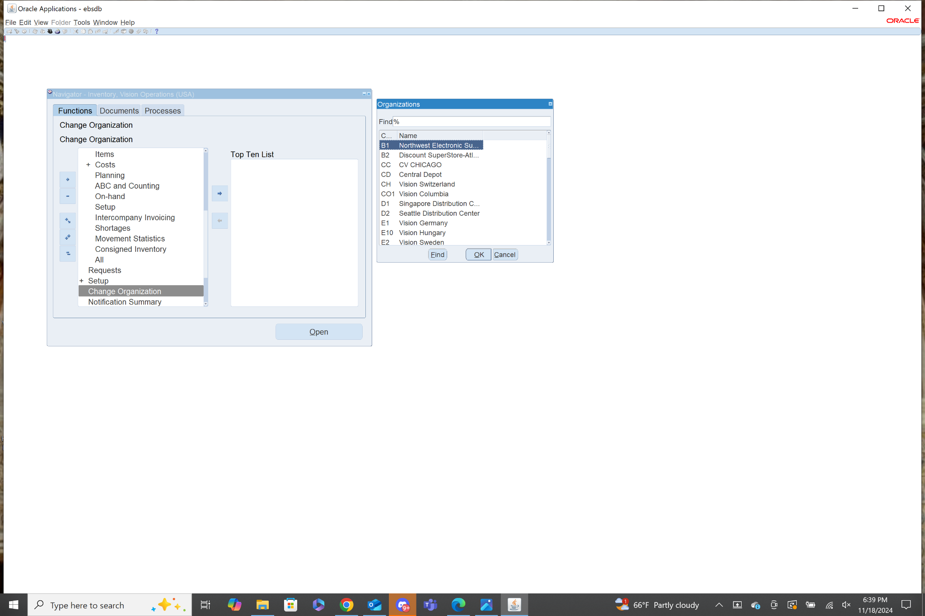

11. Master Data refers to several pieces of data that are created in the inventory responsibility, that are used to maintain consistency and data integrity throughout the application. Several Oracle Modules incorporate the usage of Master Data. They are primarily used for data that will be used in many different transactions. Some examples of master data include: Master Items, Inventory Organizations, Subinventories, and Units of Measure to name a few.

12. Navigation: **Inventory>Setup>Organizations>Organizations**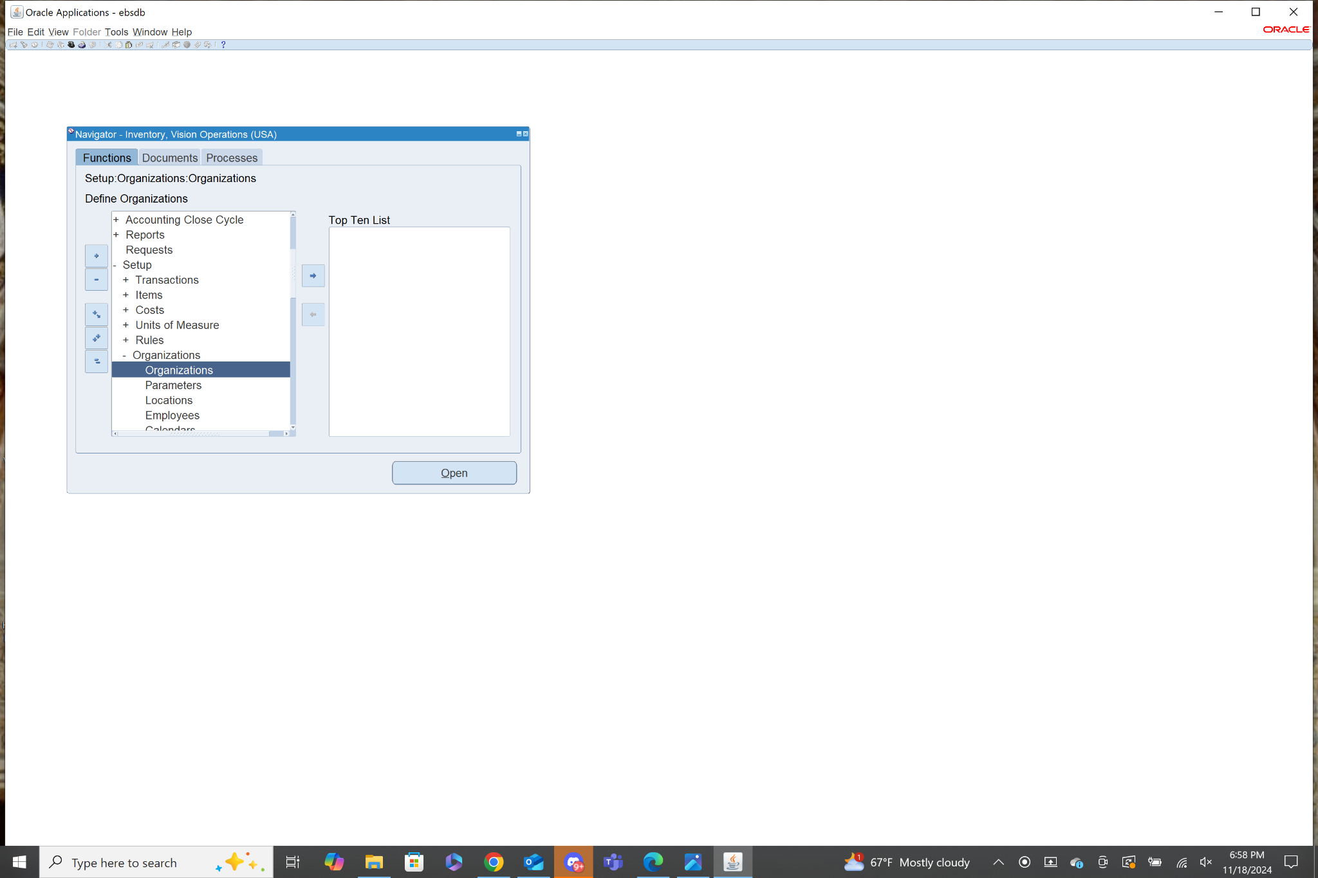

In the Find Organization form select the Name field and search for Vision Operations in the list of Values.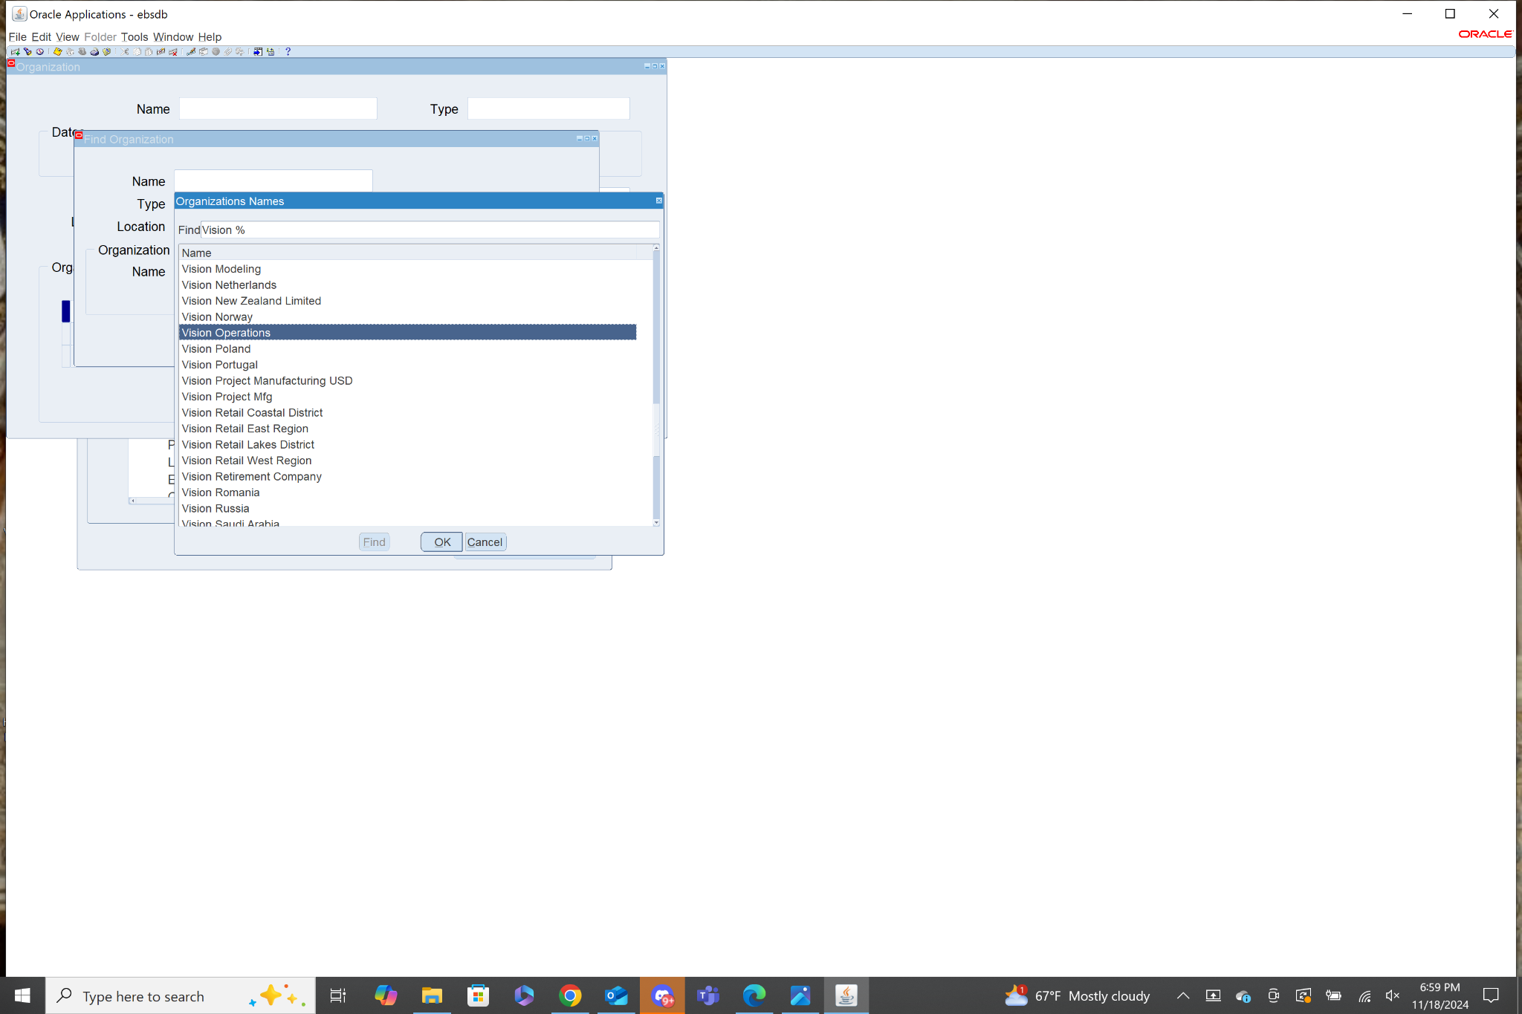

Then click Find.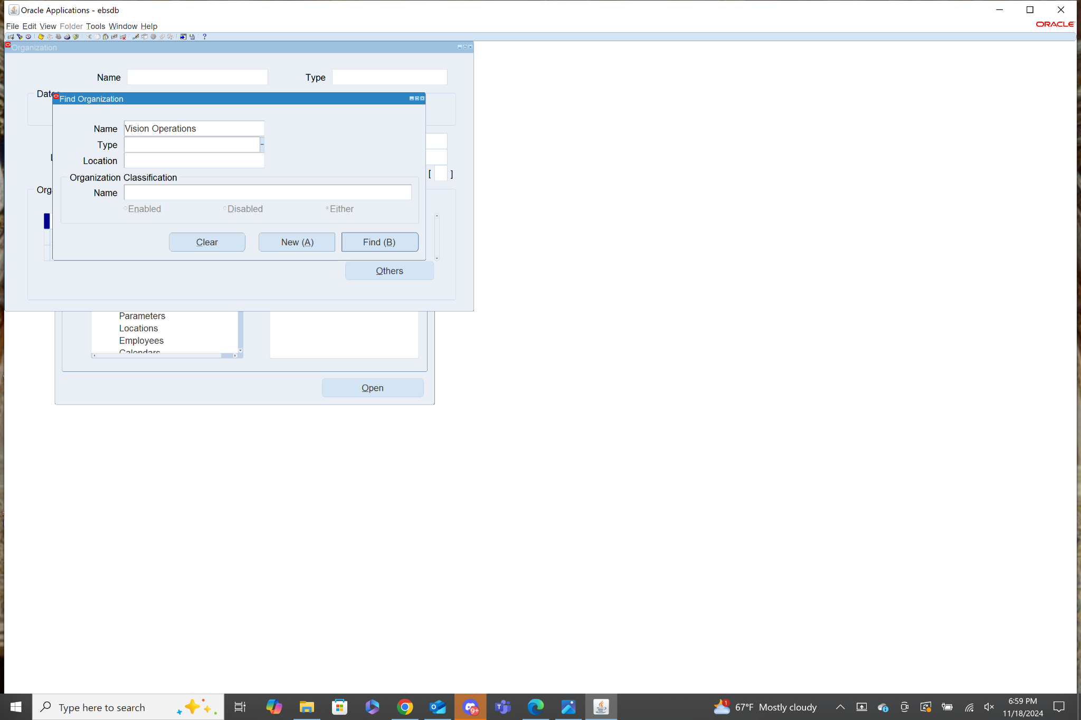

A menu with the details about the Vision Operations Org will be displayed.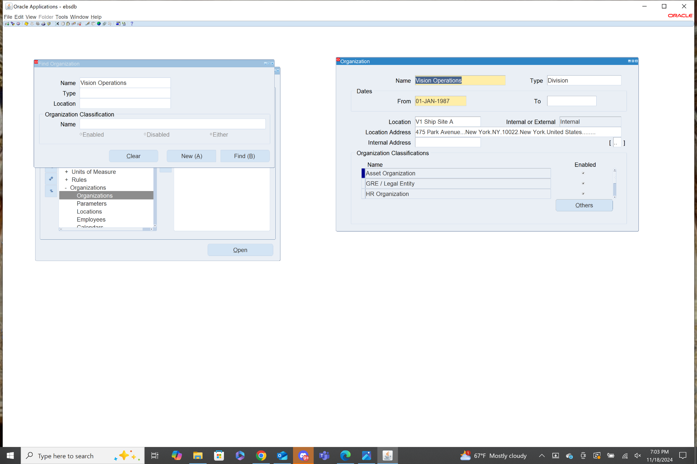

13. No. Finished goods are only one category of items that can be managed in Oracle Inventory. Using Oracle Inventory Items can be tracked from every stage including: raw materials, work-in-process items, and finished goods. There are also many other categories of items including, consumables which are consumed to bring an item to a finished stage but don’t themselves become part of the finished item. Another category is bulk items, which could include things like liquids or agricultural products.

14. True. In order for any oracle inventory transactions to occur there must be valid data in the system. Without any defined items in the system there would not be any data for the application to perform transactions on.

15. False. Subinventories are mandatory in Oracle Inventory because they represent critical information about the items, such as the physical location of an item, or the purpose of certain items. This is especially important for businesses that have more than one location to process items, so that internal supply chains remain efficient and organized.